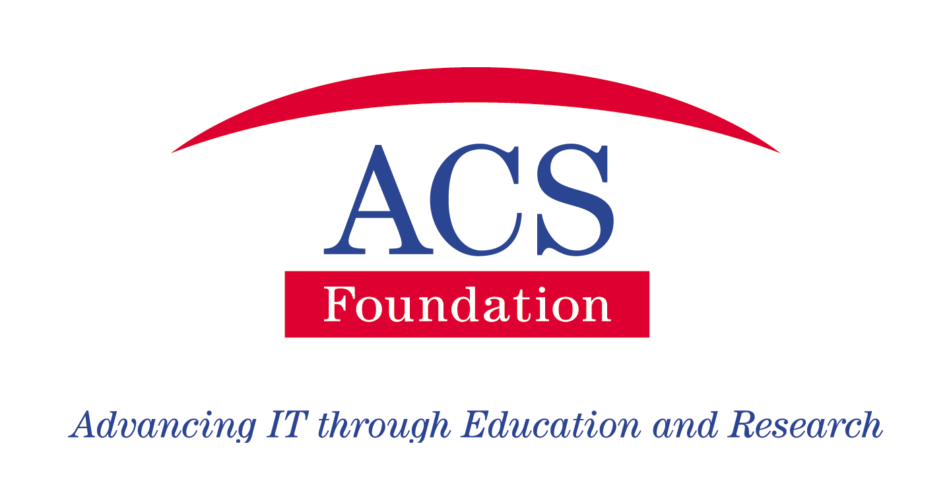

The ACS Foundation

The ACS Foundation (ACS F) was established in August 2001 by the Australian Computer Society to address a number of issues that had been identified:

- Graduates were not “work ready” and organisations generally had to invest up to 6 months in them before they became productive;
- While the industry attracted many bright students, and they enrolled into IT courses, many drifted into other disciplines either during their course or on graduation; and
- The statistics for Sydney and Melbourne showed that up to 47% of new graduates left their employer in the first 12 months.

The Australian Computer Society (ACS) felt that if it established a “value add” entity to service this area, and to provide a better experience to the industry donors, they would be more inclined to continue to support scholarships. If the students had a better experience and were able to more easily get employment on graduation, they would be more inclined to stay in the industry. And, the eventual beneficiaries would be the industry itself, having more and better graduates with more industry relevant experience.

The ACS established the ACS Foundation, which is a Designated Gift Recipient organisation of the ATO, with two broad scholarship programmes: -

- Grow A Graduate – where a donor organisation provides a scholarship for a student to do part, or all, of their course. We encourage the donor to be very specific about their requirements – the type of student, their location, the type of course they are enrolled in and the skills they wish them to have when they complete their course.

- Work Integrated Learning (WIL) – where a donor organisation provides a scholarship for an undergraduate student to experience the real workplace on a full time basis over an extended period, up to 48 weeks.

These programmes have been enthusiastically received and supported by the IT industry. Since its launch, the ACS F has raised over $7 million in contributions, and has awarded over 400 scholarships. Its students have achieved at a high level – around 35% have achieved all High Distinctions, and over 80% getting a Distinction average or better.

How the ACS Foundation WIL Scholarship Programme Works

Applicants for WIL scholarships have normally completed 2 years of their degree course, and when successful in their WIL scholarship application, they spend one year in the donor organisation, and then return to their University to complete the final year of their degree.

The Graduates

The benefits to the graduates include ensuring they graduate not only with their degree qualifications, but also with one year’s relevant valuable industry experience. Research shows they gain better grades in their final year, and they have a better and more appreciative understanding of what is valued and required by their donor organisation and the industry generally.

