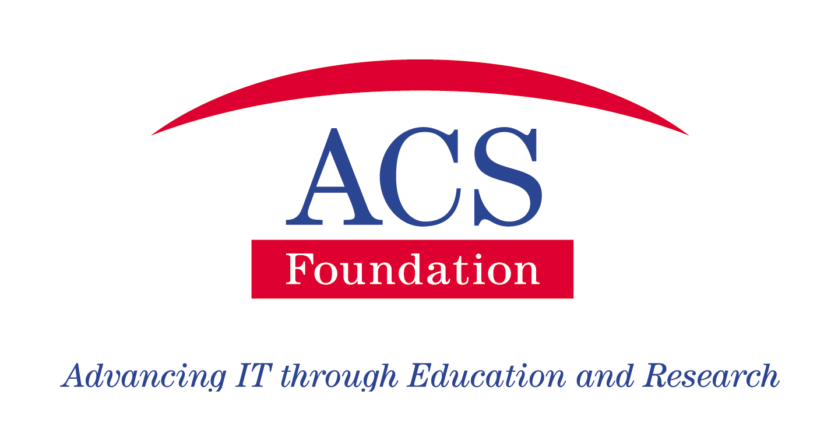

ACS Foundation

Frequently Asked Questions

About The ACS Foundation

The ACS Foundation is a tax effective, value-add entity established to identify sources of, and to raise funding for scholarships for people to study ICT and for research in ICT. These were both areas, which were felt needed to be addressed, and the ACS Foundation was set up to support these activities, which are vital for Australia and its economy in the future.

The ACS Foundation was established for a number of important reasons: -

- To be a “Value Add” entity in the Industry scholarship donor / student / institution (usually University) circular process, to ensure a better and more satisfying outcome for all participants and stakeholders;
- To provide a tax effective mechanism to enable donors and sponsors to provide funding for scholarships and research in ICT, in a tax effective way;
- To become the pre-eminent Foundation for all of the ICT industry;
- To be the focal point for the majority of funding for scholarships and research in ICT, in order to be a way of measuring and demonstrating to government the funding being provided by the ICT industry in these areas;
- By providing a better experience to all stakeholders, to encourage more funding to build better and more skilled resources for Australia, and in so doing re-establish Australia’s reputation in this area; and
- By providing high value scholarships, to attract the highest quality students, and to encourage an attitude of ICT being their career / profession of first choice.
- To encourage national and international ICT companies / governments to invest in locally initiated product research and development in emerging areas of ICT use, such as biomedical 3D imaging.

It was widely recognised that there was and still is an issue of relevancy to industry of both the majority of academic courses and the graduates of those courses. Universities cannot generally react quickly enough to change their courses to meet the needs of a rapidly changing industry such as ICT. The ACS Foundation has established a number of scholarship programmes to address these issues.
Another issue the ACS Foundation has tried to address is that of attraction of people into the industry and retention of them once they have commenced. It was found that while historically the industry attracted good numbers and high quality students, a lot of them were being lost to other disciplines during their courses. There is an additional issue currently, because there has been a significant drop in enrolments (down between 25 – 40%) over the last 3 - 4 years. This happened following the Dot Com crash, but the industry has really started to turn around and we are now facing severe shortages in skilled and experienced staff resources over the next few years.
ACS Foundation Board and Chapter members have designed this document using queries that prospective donors and students have asked regarding the ACS Foundation and it’s scholarship programmes, to address those queries.
While, in fact, the ACS Foundation has many different variations of scholarships, they are mainly comprised of two main categories of scholarships – Grow A Graduate, and Work Integrated Learning (WIL).
The essence of the ACS Foundation and its scholarships is flexibility, a strong desire to address the concerns of the industry, and to bridge the gap that exists between Universities and industry. Generally while we may offer our advice to our donors, as long as their requirements meet certain “statutory” requirements, we will be flexible in order to meet their individual requirements.
General Questions

What has the ACS Foundation achieved so far?
Since its establishment in August 2001 the ACS Foundation has raised over $8 million in cash and in-kind donations towards its programmes. We have awarded over 550 scholarships to students, with those students achieving pleasingly high results – around 35% have achieved all HDs, and over 80% have achieved a Distinction average or better in their subjects.
What benefits do the ACS Foundation programmes deliver to the donor organisations?
There are a number of significant cost savings for donors to the ACS Foundation scholarships. Because the ACS Foundation is a designated gift recipient (DGR) organisation, all donations are fully tax deductible.
They enable the donors to address the issue of relevancy of graduates, by two different ways – the Grow a Graduate programme allows the donor to specify the skills they want their graduate to have and the WIL programme allows the donor to train the student in actual work place conditions, and also gives the student first-hand experience so that they are better able to select relevant subjects and modules when they go back to finish their degree.
Do Information Systems students qualify?
All ACS Foundation scholarships, including WIL scholarships, are available to students enrolled in all the ICT related disciplines, depending on the requirements of the donor/s, and the ability of the university and their courses where the students are enrolled to meet the requirements.
What types of scholarships do the ACS Foundation seek to award?
It seeks to identify any and all types of scholarships that donors wish to contribute to. It does try to raise funding for EEO type scholarships as well as merit based scholarships.
What has been the donors experience to date with ACS Foundation students?
Their experiences to date have been universally very pleasing and satisfactory. There are a number of reference donors available for other donors to talk to about their experiences, but one fact has been the high standard of ACS Foundation students. We work hard to ensure a good match between the donor and the student and if the right applicant is not found in the first round we encourage the donor to try again to ensure their satisfaction.
How does an organisation establish a scholarship?
Once the organisation has decided it wants to donate a scholarship, it needs to sign a donor MOU document that outlines their commitment in terms of dollars, number of scholarships, and commencement dates. The details of the scholarship will be advertised and applications sought. Once a short list of applicants has been chosen, the donor can participate in the final selection process if they wish.
Once the successful applicant is chosen, they will sign a student agreement with the ACS Foundation.
Grow a Graduate Scholarship programme
Our “Grow A Graduate” scholarships are more of the nature of traditional philanthropic scholarships, but where we encourage the donor organisation to be very specific about the type of person required, from which region or area, maybe at which university/universities, and what skills they require of that graduate. We then set about finding appropriate applicants who meet their requirements.

How much does a Grow A Graduate scholarship cost?
The cost of the scholarship is really up to the donor to decide how much they wish to donate. It is better for the students, especially those from regional or rural locations, if the scholarships can go for the life of their degree. Unless this is the case there can sometimes be a reluctance to take the scholarship up, as it may result in a commitment and burden for the family at the end of the scholarship for the student to continue their course. Generally, the higher the value of the scholarship the more competitively it is sought after, and the higher the quality of the applicants for it.
How does a Grow A Graduate scholarship work?
The ACS Foundation tries to encourage a strong relationship between the donor organisation and the students. It investigates opportunities to combine periods of work integrated learning into the Grow A Graduate scholarship, if the donor is receptive, and it is appropriate, because of the recognised value to all parties of WIL. Any mutually acceptable period such as during semester breaks, or even during a semester, can be investigated. These arrangements can be of great value to the students by offering them real life work experience and skills, and assisting them further with the issue of relevancy.

Work Integrated Learning (WIL) Scholarship programme
The great value of work experience to students is that it gives them the advantage of graduating with both a degree and work experience, experiencing a real work place and job situation, while at the same time allowing them the opportunity to understand what skills are relevant to employers. There is also value to both employer and student, as it enables both parties to establish whether there is a basis for a potential ongoing longer-term relationship, such as offering employment at the completion of their degree. There has been research to show that the WIL type arrangement significantly increases the retention of staff.
The ACS Foundation WIL scholarships cater for periods of workplace learning. We have found that these scholarships result in the graduates having more industry relevant skills, as well as being able to present themselves to prospect employers as having had that work experience. We have also found that in addresses a productivity issue, by ensuring that the graduate is able to be productive from the day they start employment, instead of requiring 3 – 6 months on the job training before they are productive.
However, the work experience can vary from one per week (generally over one or two semesters) where the student still attends university on other days, to full time for varying periods where the student is not doing lectures at the same time. The critical factor has to be for the work experience to best suit the requirements of the donor/s.
A couple of generic examples of how organisations are using the WIL scholarships may be helpful –
Example A – an organisation is providing a number of scholarships for students to gain valuable skills by completing projects for them under a 48 week WIL scholarship. The students experience real workplace conditions while doing those projects and gaining their skills, and the organisation gets the opportunity to evaluate the students over an extended period.
Example B – an organisation takes an intake of students every 6 months on 48 week WIL scholarships, rather than take them all at the same time, in order to stagger the impact on the organisation.
Example C - an organisation has a WIL student for one day per week over a two-semester period.
The standard 48-week scholarship is generally delivered over a 52-week period to allow for periods when the student may not be available, but is still able to complete the full 48 weeks.
What benefits do the WIL scholarships deliver to the organisation?
The WIL scholarship programme helps donor organisations address the retention issue for first year graduates. Research has shown that (in Sydney and Melbourne) around 47% of first year graduates leave their first job in the first 12 months. Considering that most organisations need to spend 3-6 months training their new graduates before they are able to be productive, this results in a huge investment working out the front door. The research showed that 70% of students who had been through a WIL-type programme were still with their employer after 7 years. This is a significant saving to the organisation.
There are other cost savings that result from WIL scholarships compared to employment, which include no workers compensation, no additional employment related on-costs such as payroll tax or superannuation, and no industrial-relations complications.
Is it essential that the student complete a full year work experience? Would a summer vacation work experience be acceptable?
No – in fact any period is acceptable – but ideally it should be what suits the donor and not what suits the University. We run many different programmes varying from one day per week, to various periods of full time.
Is there a “standard” ACS Foundation WIL scholarship?
Yes – the “standard” ACS Foundation WIL scholarship is a 48-week scholarship, which is taken over 52 weeks to allow for any periods when the student may be absent, but still fulfil their obligation to complete the 48 weeks. This normal cost to the donor of this scholarship is $34,000, but this amount may vary depending on local conditions and the ability of the donor to fund the scholarship. Normally (as a rule of thumb) the WIL scholarship would cost the donor between $100 - $125 per day, and the number of days of the scholarship can easily be calculated by dividing the amount the donor is willing to pay by those amounts. For WIL scholarships there is an amount included in the scholarship to meet the associated administration costs, which is normally around 15%.

Does ACS Foundation provide the links to work experience donors?
The short answer is “yes”. We like to work with the universities and their current donors as well as introducing new donors to them. It really does depend on individual donor requirements. We have a number of national as well as state based donors with opportunities available, and the demand for WIL type students are increasing rapidly.
The most popular WIL scholarships with many donors are the full time, 1- (24 week) or 2-Semester (48 week) scholarships – how do they work?
To be eligible as a scholarship there are a number of criteria that must be met. The student must be enrolled in a degree programme where the work experience project has a subject number and counts credit points towards the degree.
How does the one-year full time work experience fit into a degree? Does it mean that a 4-yr degree has to be created to cover this?
In the case of either one or two Semester periods of full time work experience it does mean that generally the length of the time to complete the degree has to be increased. The exception to that is if the work experience can be accommodated during semester breaks and completed in the normal 3 years. The two degrees can have the same academic content, with two different names, and those students who do the WIL period get the degree with the WIL recognition.
Is there a risk that students won't complete the degree if they are
offered a job?
There is a chance this may happen, and it may happen in any case – however, the ACS Foundation strongly discourages both donors and students to do this, and encourage the student to complete their degree.
How many students are likely to be involved? (Based on experience at
other universities)
This depends on a number of different factors and is not easily or quantified for a particular university. It is also something that can to an extent be controlled or managed. It is a degree programme that can be phased in by the university over a few years if it doesn’t already have one, by making a specific number of places available for this particular degree each year.
If large numbers apply, that means numbers will be down in the 3rd yr,
thus affecting revenue?
Generally, the experience has been the opposite – the WIL programmes are the most highly competitive and enrolments are up and not showing the decline that most other ICT courses are. The effect should only be for the first year in any case. (Also, see answer above)

Do overseas students qualify for this? How?
Overseas students can apply as long as they are enrolled in an appropriate course at an Australian university and have residency.
What benefits do WIL scholarships provide to students?

One of the major benefits that WIL scholarships provide to the students besides the real work skills they learn, and the opportunity to understand the skills that are relevant to industry, is the exposure to potential future employers and the opportunity for the student to impress the organisation. This combined with the benefit of being able to graduate with work experience as well as their degree is a major benefit.

